ServiceNow Application Documentation
Automated Network Request Management
1. Introduction
Project Title: Automated Network Request Management
Team Members: Puchakayala Asritha — Team ID: Servicenow. Solo contributor responsible for end-to-end delivery: Service Catalog design, Flow Designer automation, security configuration (roles/ACLs), and testing.
2. Project Overview
Purpose
The project automates the intake, approval, and fulfilment of employee network service requests on the ServiceNow platform, replacing a manual, email-driven process with a structured, trackable digital workflow.
Features
- Guided Service Catalog item (Network Request) with catalog variables and a reusable variable set
- Conditional field visibility via a Catalog UI Policy (Existing ID field)
- No-code automation through Flow Designer: record creation, email notifications, and approval routing
- Native ServiceNow Approval engine with If/Else branching on the outcome
- Dedicated custom table (Database Tables) with an auto-numbered (NRM-prefixed) identifier
- Role-based access control via auto-generated ACLs scoped to the u_database_tables_user role
3. Architecture
Frontend (Service Portal)
The requester-facing layer is ServiceNow's standard Service Portal (Now Experience UI), accessed at instance-url/sp. Requesters interact with the Network Request catalog item, a guided form built from catalog variables and the Request Information variable set, rather than a custom-coded UI.
Backend (Flow Designer & Approval Engine)
Application logic is implemented declaratively in Flow Designer rather than server-side code: the flow retrieves submitted catalog variables, creates the request record, sends email notifications, and routes the request through ServiceNow's native Approval engine, branching on the approval outcome using Flow Logic (If/Else).
Database (Database Tables)
Request data is stored in a custom table, Database Tables (u_database_tables), with fields for requester, connection type, address, payment details, and approval status, plus an auto-numbered identifier prefixed NRM. An Approval Request relationship links each record to its ServiceNow approval history.
4. Setup Instructions
Prerequisites
- A ServiceNow Personal Developer Instance (PDI) with admin access
- Familiarity with Service Catalog, Flow Designer, and System Update Sets
Installation
1. Provision or log in to a ServiceNow PDI.
2. Navigate to System Update Sets > Retrieved Update Sets and select Import Update Set from XML.
3. Upload the provided update set file (sys_remote_update_set – Automated Network Request Management).
4. Open the imported update set, click Preview Update Set, then Commit Update Set.
5. Verify that the Network Request catalog item, Database Tables table, Network Request flow, u_database_tables_user role, and associated ACLs have all been created.
5. Application Structure
ServiceNow configuration does not use a client/server folder layout; the equivalent logical structure is:
- Tables: Database Tables (u_database_tables) — stores request records
- Service Catalog: Network Request item + Request Information variable set + Catalog UI Policy
- Process Automation: Network Request flow (Flow Designer)
- Security: u_database_tables_user role + auto-generated ACLs
- Packaging: Update Set — Automated Network Request Management
6. Accessing the Application
There is no local build step (no npm/server commands) since the solution runs entirely on the hosted ServiceNow instance:
1. Log in to the ServiceNow instance.
2. Open the Service Portal at instance-url/sp.
3. Search for “Network Requests” in the portal catalog and submit a request.
4. Approvers review pending approvals from their ServiceNow inbox or the Approvals module.
7. API Documentation
No custom Scripted REST APIs were built for this project. The custom table is automatically exposed through ServiceNow's native Table API:
GET /api/now/table/u_database_tables
POST /api/now/table/u_database_tables
PUT /api/now/table/u_database_tables/{sys_id}
DELETE /api/now/table/u_database_tables/{sys_id}
Access to these endpoints is governed by the same role-based ACLs used within the platform UI, so only users with the u_database_tables_user role can read or write request records via the API.
8. Authentication
Authentication is handled by ServiceNow's platform-level session authentication (username/password, or SSO where configured for the instance). Authorization is enforced separately through role-based Access Control Lists: only users holding the u_database_tables_user role can create, read, update, or delete records on the Database Tables table.
9. User Interface & Screenshots
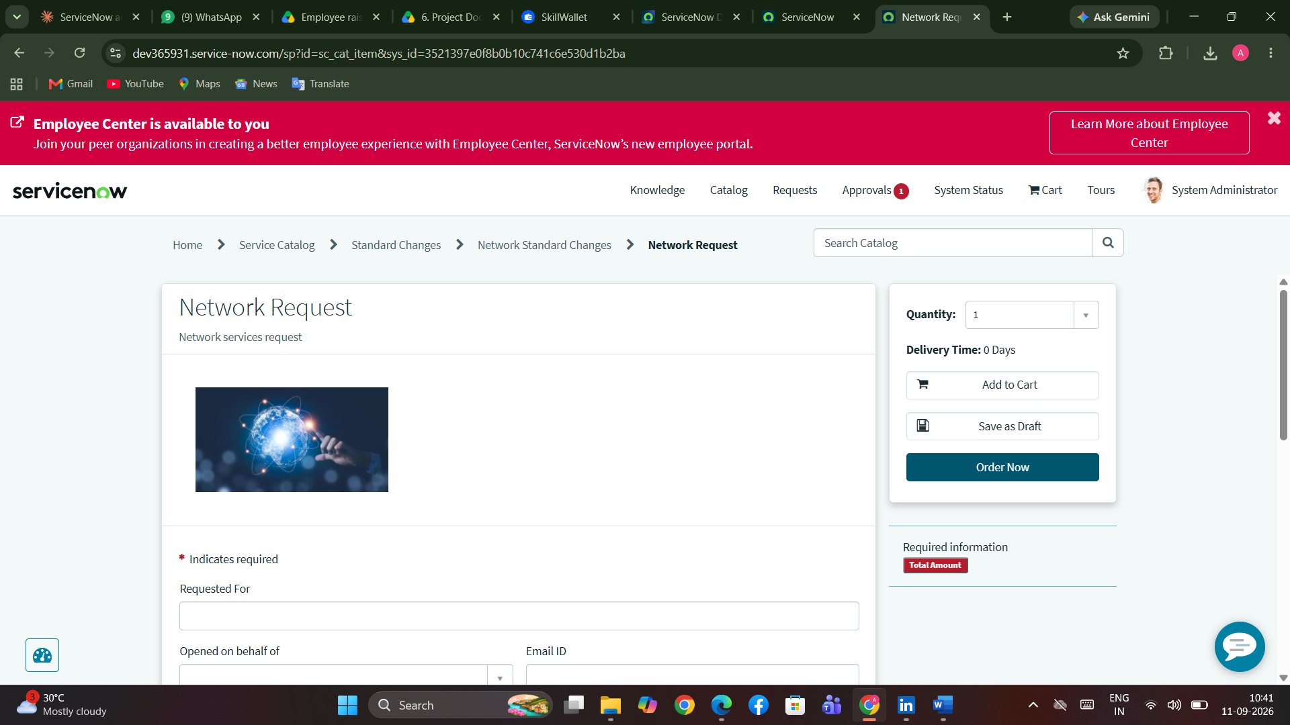
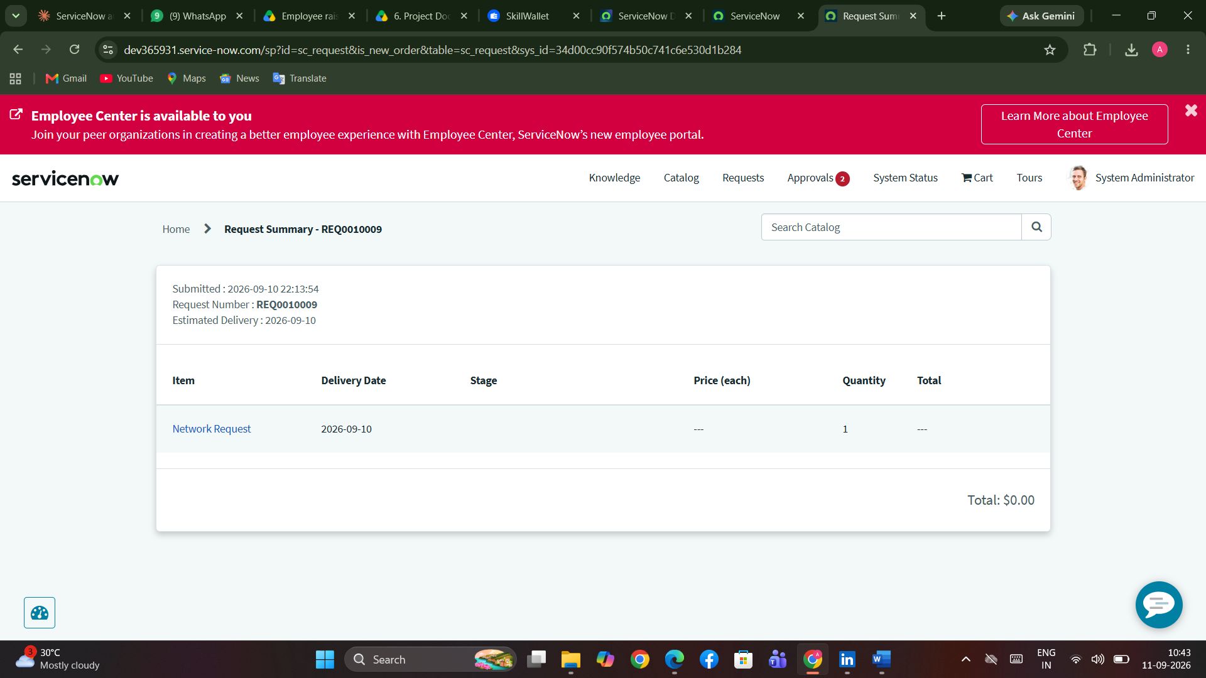
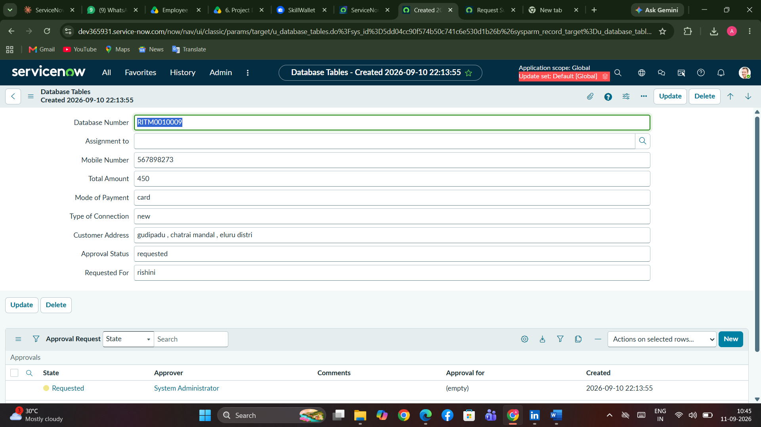10. Testing
The solution was validated through User Acceptance Testing (see the UAT Report and UAT FSD documents from the Project Development phase): 9 detailed test cases (TC-001 to TC-009) covered request submission, conditional field behaviour, record creation, approval routing, and access control — all passing. A defect analysis logged 17 issues across severity levels during testing, the majority resolved as Fixed or By Design.
11. Known Issues
- BG-003: Resubmitting the same browser tab after a request has already been submitted can trigger a duplicate flow run. Logged as Won't Fix for the current release and documented as a known limitation.
12. Future Enhancements
- Auto-provisioning through integrations with network tools such as Cisco DNA Center or Ansible
- Orchestration flows using ServiceNow Integration Hub
- Reporting dashboards for request volume and fulfilment metrics
- Expansion of the same catalog + flow pattern to other IT services, such as device provisioning and access requests

